
Cloudli Connect Training
How to Utilize the Receptionist Console
Lynn Daviault | 1/5/26 | Cloudli Connect Training

How to Utilize the Receptionist Console
This guide is essential for anyone using the receptionist console, as it provides clear instructions on managing calls effectively. It highlights the console's capabilities, such as transferring calls, parking them, and handling multiple extensions, ensuring efficient call management. Understanding these features will enhance your ability to control calls and improve communication within your organization. By following this guide, you can maximize the functionality of the receptionist console and streamline your workflow.

- To access the receptionist console, expand the Telephony menu, then expand Receptionist and select Console. If this option is not visible, it indicates that the appropriate license has not been assigned to the account or user.
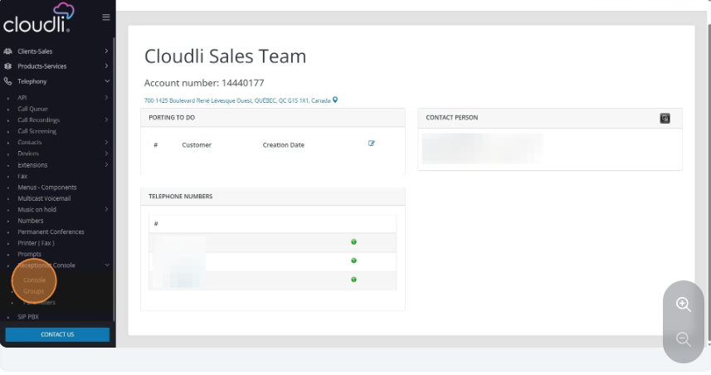
- The Receptionist Console is limited to use by one user at a time. It is not a phone, but rather a call control interface that must be used in conjunction with an IP phone or softphone. The console is designed specifically for call handling, allowing the user to transfer calls, send calls directly to voicemail, park calls, and transfer calls to queues or hunt groups.
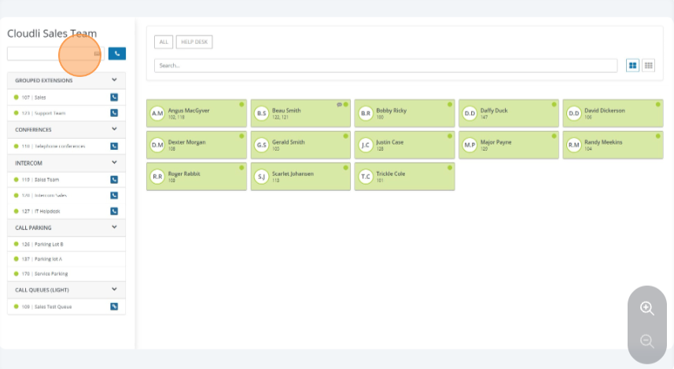
- Once you are in the Receptionist Console, you will have visibility into various hunt groups, grouped extensions, conference lines, intercoms, call parking lots, and queues. You can also view the status of individual users to see who is currently on a call. Additionally, any notes entered by employees within Call Manager can be accessed by clicking the Messages icon.
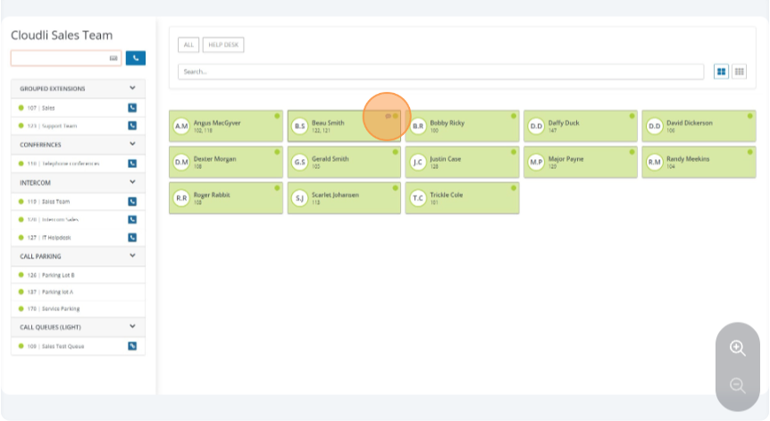
- Active calls will appear in the upper-left section of the Receptionist Console. From this view, you can monitor and transfer calls to various hunt groups, grouped extensions, conference bridges, call parking lots, and queues. When a user is on a call, their status will be highlighted in red.
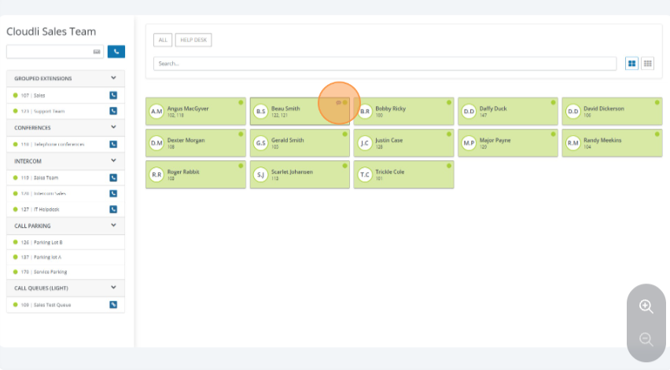
- If an employee has entered notes in Call Manager, a Messages icon will appear next to their status. Clicking the icon will display the note. This feature is useful for communicating out-of-office, lunch breaks, vacation, or other status updates.

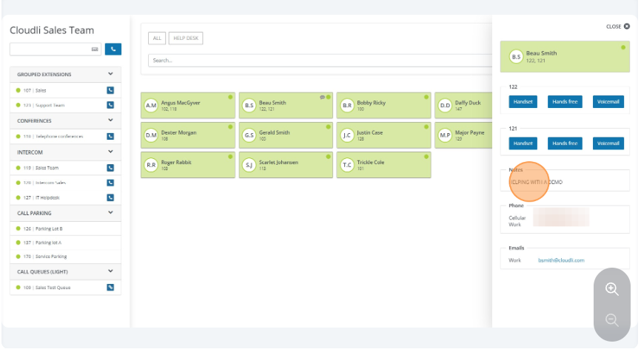

- Once you have answered a call, simply click and drag it to the desired destination for transfer.
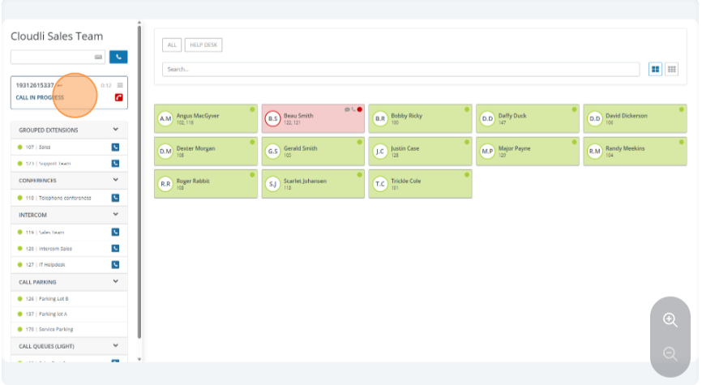
- In this example, the call will be dragged and dropped to a user who is already on a call. If the user has multiple extensions in the system, all available options for each extension will be displayed. You can perform a standard transfer, a transfer with call parking, or transfer directly to voicemail. With a transfer with call parking, the call is placed on hold and the caller hears music on hold. Every 30 seconds, the busy party will receive two rings to notify them that a caller is waiting. Once the user becomes available, the call will be transferred to their extension.
